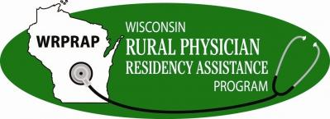

WRPRAP Grant Evaluation

Please indicate which report you are submitting:
Midterm Report
Final Report*
*Any remaining funds must be reported and returned to WRPRAP, within 30 days of project end date. Or a Grant Funding Extension Request Form must be submitted to carry-over remaining funding. Only for Non-UW Grant Awardees.

Contact Information
Name:
Email:
Date:

Program Information
Organization:
Grant ID Number:
Award Period:
Amount Awarded:

PROGRESS SUMMARY
Write a brief outline of the grant goals (as submitted in application).

Have you changed your long-term goals for this project? If so, what are the implications for resources, execution of plans, time line or other factors?

BUDGET
Are you on track with your proposed budget? If no, describe any changes or differences between the proposed and actual budget, as of today's date.

*Attach supported documentation of actual expenditures in comparison to proposed budget, using the Evaluation Report Budget Template found here, https://www.fammed.wisc.edu/rural/grantee-reporting/)

ACCOMPLISHMENTS & CHALLENGES
Describe how and to what extent you met your goals by clearly showing your accomplishments with this funding.

What, if any, unanticipated challenges and barriers presented themselves over the course of this grant period? How were these addressed and to what effect?

CLOSING (only for Final Year-End Evaluations)
Any unused funds must be reported and returned to WRPRAP, within 30 days of project end date.
Or
A Grant Funding Extension Request Form can be completed and submitted to carry-over unused funding. (https://www.fammed.wisc.edu/rural/application-grant-forms/)

What lessons were learned, and what implications do they have on how your organization will advance with your grant goals?

How did your program contribute to WRPRAP's primary goal of enhancing the quality and number of graduate medical education opportunities in rural Wisconsin communities?

Do you intend to apply for additional funding from WRPRAP within the next 18 months? If yes, please describe briefly.

Other comments:

Optional: Upload any additional files that support the progress and reporting of your grant.

Please review all your responses prior to submitting this report.
By checking this box, I acknowledge that the information provided throughout this report is true and accurate.

Signature Date

Print Name

