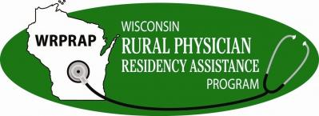

WRPRAP Grant Funding Reallocation Request
Please return form to WRPRAP@fammed.wisc.edu
For questions please contact us at (608) 263-5062

Contact Information
Requester Name:
Requester Email:
Date:

Program Information
Organization:
Grant ID Number:
Award Period:
Amount Awarded:
Remaining Award Balance:

Justification
In the space below, please provide the following information for the reallocation request:
- Brief explanation for the reallocation including the reason(s) the funds were not used as originally planned;
- Brief explanation of the proposed use of reallocated funds.

BUDGET
Use WRPRAP budget template, (https://www.fammed.wisc.edu/rural/application-grant-forms/)
Attach supported documentation, of actual expenditures for:
- Original submitted budget, and breakdown of used and remaining funds.
- Proposed budget for reallocated funds.

Optional: Upload any additional files that support the progress and reporting of your grant.

Please review all your responses prior to submitting.

We acknowledge that the information provided is true and accurate.

Awardee Signature: Date

Awardee Print Name:

This section is to be completed by Wisconsin Rural Physician Residency Assistance Program (WRPRAP).

Wisconsin Rural Physician Residency Assistance Program (WRPRAP) has reviewed the submitted request, and approves extension of funds for (start date) through (end date) for (program name). Evaluation reports must be completed and submitted by (mid-report date) and (final report date).

WRPRAP Signature: Date

WRPRAP Print Name:

